Multicultural and Social Justice Counseling Competencies

Developed by

The Multicultural Counseling Competencies Revisions Committee: Dr. Manivong J. Ratts, chair (Seattle University)
Dr. Anneliese A. Singh (University of Georgia)

Dr. Sylvia Nassar-McMillan (North Carolina State University), Dr. S. Kent Butler (University of Central Florida)
Julian Rafferty McCullough (Georgia State University)

Appointed by

Dr. Carlos Hipolito-Delgado

President, Association for Multicultural Counseling and Development (2014-2015)

Endorsed on June 29, 2015 by

Association for Multicultural Counseling and Development Executive Council A Division of the American Counseling Association

Endorsed on July 20, 2015 by

American Counseling Association Governing Council

Table of Contents
- Overview 3
- Multicultural and Social Justice Counseling Competencies Conceptual Framework...4
- Multicultural and Social Justice Counseling Competencies 5-14

Multicultural and Social Justice Counseling Competencies

The Multicultural and Social Justice Counseling Competencies (MSJCC), which revises the Multicultural Counseling Competencies (MCC) developed by Sue, Arredondo, and McDavis (1992) offers counselors a framework to implement multicultural and social justice competencies into counseling theories, practices, and research. A conceptual framework (See Figure 1) of the MSJCC is provided to illustrate a visual map of the relationship between the constructs and competencies being articulated within the MSJCC. Moreover, quadrants are used to highlight the intersection of identities and the dynamics of power, privilege, and oppression that influence the counseling relationship. Developmental domains reflect the different layers that lead to multicultural and social justice competence: (1) counselor self-awareness, (2) client worldview, (3) counseling relationship, and (4) counseling and advocacy interventions.
Embedded within the first three developmental domains of the MSJCC are the following aspirational competencies: attitudes and beliefs, knowledge, skills, and action (AKSA). The socioecological model is incorporated within the counseling and advocacy interventions domain to provide counselors a multilevel framework for individual counseling and social justice advocacy.

Figure 1

Multicultural and Social Justice Counseling Competencies

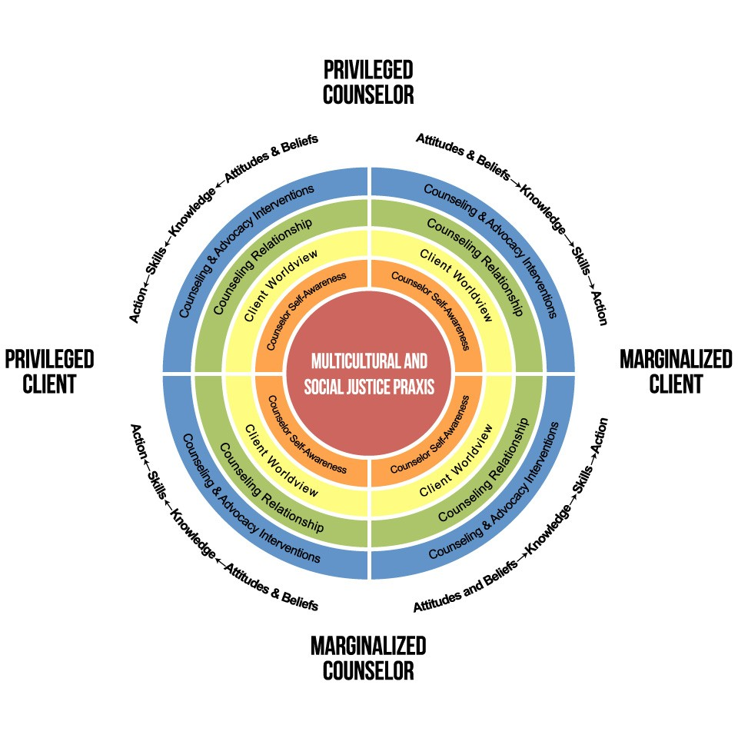

Figure 1: Multicultural and Social Justice Counseling Competencies Retrieved from http://www.counseling.org/knowledge-center/competencies. Copyright 2015 by M.J. Ratts, A.A. Singh, S. Nassar-McMillan, S.K. Butler, & J.R. McCullough. Reprinted with permission.

Multicultural and Social Justice Counseling Competencies

- Counselor Self-Awareness

Privileged and marginalized counselors develop self-awareness, so that they may explore their attitudes and beliefs, develop knowledge, skills, and action relative to their self-awareness and worldview.

  - Attitudes and beliefs: Privileged and marginalized counselors are aware of their social identities, social group statuses, power, privilege, oppression, strengths, limitations, assumptions, attitudes, values, beliefs, and biases.

Multicultural and social justice competent counselors:
    - Acknowledge their assumptions, worldviews, values, beliefs, and biases as members of privileged and marginalized groups.
    - Acknowledge their privileged and marginalized status in society.
    - Acknowledge their privileged and marginalized status influences their worldview.
    - Acknowledge their privileged and marginalized status provides advantages and disadvantages in society.
    - Acknowledge openness to learning about their cultural background as well as their privileged and marginalized status.

  - Knowledge: Privileged and marginalized counselors possess an understanding of their social identities, social group statuses, power, privilege, oppression, strengths, limitations, assumptions, attitudes, values, beliefs, and biases.

Multicultural and social justice competent counselors:
    - Develop knowledge of resources to become aware of their assumptions, worldviews, values, beliefs, biases, and privileged and marginalized status.
    - Develop knowledge about the history and events that shape their privileged and marginalized status.
    - Develop knowledge of theories that explain how their privileged and marginalized status influences their experiences and worldview.
    - Develop knowledge of how their privileged and marginalized status leads to advantages and disadvantages in society.

  - Skills: Privileged and marginalized counselors possess skills that enrich their understanding of their social identities, social group statuses, power, privilege, oppression, limitations, assumptions, attitudes, values, beliefs, and biases.

Multicultural and social justice competent counselors:
    - Acquire reflective and critical thinking skills to gain insight into their assumptions, worldviews, values, beliefs, biases, and privileged and marginalized status.

    - Acquire communication skills to explain how their privileged and marginalized status influences their worldview and experiences.
    - Acquire application skills to interpret knowledge of their privileged and marginalized status in personal and professional settings.
    - Acquire analytical skills to compare and contrast their privileged and marginalized status and experiences to others.
    - Acquire evaluation skills to assess the degree to which their privileged and marginalized status influences their personal and professional experiences.

  - Action: Privileged and marginalized counselors take action to increase self- awareness of their social identities, social group statuses, power, privilege, oppression, strengths, limitations, assumptions, attitudes, values, beliefs, and biases.

Multicultural and social justice competent counselors:
    - Take action to learn about their assumptions, worldviews, values, beliefs, biases, and culture as a member of a privileged and marginalized group.
    - Take action to seek out professional development opportunities to learn more about themselves as a member of a privileged or marginalized group.
    - Take action to immerse themselves in their community to learn about how power, privilege, and oppression influence their privileged and marginalized experiences.
    - Take action to learn about how their communication style is influenced by their privileged and marginalized status.

Client Worldview

Privileged and marginalized counselors are aware, knowledgeable, skilled, and action-oriented in understanding clients’ worldview.

  - Attitudes and beliefs: Privileged and marginalized counselors are aware of clients’ worldview, assumptions, attitudes, values, beliefs, biases, social identities, social group statuses, and experiences with power, privilege, and oppression.

Multicultural and social justice competent counselors:
    - Acknowledge a need to possess a curiosity for privileged and marginalized clients’ history, worldview, cultural background, values, beliefs, biases, and experiences.
    - Acknowledge that identity development influences the worldviews and lived experiences of privileged and marginalized clients.
    - Acknowledge their strengths and limitations in working with clients from privileged and marginalized groups.
    - Acknowledge that learning about privileged and marginalized clients may sometimes be an uncomfortable or unfamiliar experience.

    - Acknowledge that learning about clients’ privileged and marginalized status is a lifelong endeavor.
    - Acknowledge the importance of reflecting on the attitudes, beliefs, prejudices, and biases they hold about privileged and marginalized clients.
    - Acknowledge that there are within-group differences and between group similarities and differences among privileged and marginalized clients.
    - Acknowledge clients’ communication style is influenced by their privileged and marginalized status.

  - Knowledge: Privileged and marginalized counselors possess knowledge of clients’ worldview, assumptions, attitudes, values, beliefs, biases, social identities, social group statuses, and experiences with power, privilege, and oppression.

Multicultural and social justice competent counselors:
    - Develop knowledge of historical events and current issues that shape the worldview, cultural background, values, beliefs, biases, and experiences of privileged and marginalized clients.
    - Develop knowledge of how stereotypes, discrimination, power, privilege, and oppression influence privileged and marginalized clients.
    - Develop knowledge of multicultural and social justice theories, identity development models, and research pertaining to the worldview, culture, and life experiences of privileged and marginalized clients.
    - Develop knowledge of their strengths and limitations in working with clients from privileged and marginalized groups.
    - Develop knowledge of how to work through the discomfort that comes with learning about privileged and marginalized clients.
    - Develop a lifelong plan to acquire knowledge of clients’ privileged and marginalized status.
    - Develop knowledge of the attitudes, beliefs, prejudices, and biases they hold about privileged and marginalized clients.
    - Develop knowledge of the individual, group, and universal dimensions of human existence of their privileged and marginalized clients.
    - Develop knowledge of the communication style of their privileged and marginalized client (e.g., high context vs. low context communication, eye contact, orientation to time and space, etc.).

  - Skills: Privileged and marginalized counselors possess skills that enrich their understanding of clients’ worldview, assumptions, attitudes, values, beliefs, biases, social identities, social group statuses, and experiences with power, privilege, and oppression.

Multicultural and social justice competent counselors:
    - Acquire culturally responsive evaluation skills to analyze how historical events and current issues shape the worldview, cultural background,

values, beliefs, biases, and experiences of privileged and marginalized clients.
    - Acquire culturally responsive critical thinking skills to gain insight into how stereotypes, discrimination, power, privilege, and oppression influence privileged and marginalized clients.
    - Acquire culturally responsive application skills to apply knowledge of multicultural and social justice theories, identity development models, and research to one’s work with privileged and marginalized clients.
    - Acquire culturally responsive assessment skills to identify limitations and strengths when working with privileged and marginalized clients.
    - Acquire culturally responsive reflection skills needed to work through the discomfort that comes with learning about privileged and marginalized clients.
    - Acquire culturally responsive conceptualization skills to explain how clients’ privileged and marginalized status influence their culture, worldview, experiences, and presenting problem.
    - Acquire culturally responsive analytical skills to interpret the attitudes, beliefs, prejudices, and biases they hold about privileged and marginalized clients.
    - Acquire culturally responsive conceptualization skills to identify the individual, group, and universal dimensions of human existence of privileged and marginalized clients.
    - Acquire culturally responsive cross-cultural communication skills to interact with privileged and marginalized clients.

  - Action: Privileged and marginalized counselors take action to increase self- awareness of clients’ worldview, assumptions, attitudes, values, beliefs, biases, social identities, social group statuses, and experiences with power, privilege, and oppression.

Multicultural and social justice competent counselors:
    - Take action by seeking out formal and informal opportunities to engage in discourse about historical events and current issues that shape the worldview, cultural background, values, beliefs, biases, and experiences of privileged and marginalized clients.
    - Take action by attending professional development trainings to learn how stereotypes, discrimination, power, privilege, and oppression influence privileged and marginalized clients.
    - Take action by applying multicultural and social justice theories, identity development models, and research to one’s work with privileged and marginalized clients.
    - Take action by assessing ones limitations and strengths when working with privileged and marginalized clients on a consistent basis.
    - Take action by immersing oneself in the communities in which privileged and marginalized clients reside to work through the discomfort that comes with learning about privileged and marginalized clients.

    - Take action by using language to explain how clients’ privileged and marginalized status influence their culture, worldview, experiences, and presenting problem.
    - Take action by pursuing culturally responsive counseling to explore the attitudes, beliefs, prejudices, and biases they hold about privileged and marginalized clients.
    - Take action by collaborating with clients to identify the individual, group, and universal dimensions of human existence that shape the identities of privileged and marginalized clients.
    - Take action by consistently demonstrating cross-cultural communication skills required to effectively interact with privileged and marginalized clients.

Counseling Relationship

Privileged and marginalized counselors are aware, knowledgeable, skilled, and action-oriented in understanding how client and counselor privileged and marginalized statuses influence the counseling relationship.

  - Attitudes and beliefs: Privileged and marginalized counselors are aware of how client and counselor worldviews, assumptions, attitudes, values, beliefs, biases, social identities, social group statuses, and experiences with power, privilege, and oppression influence the counseling relationship.

Multicultural and social justice competent counselors:
    - Acknowledge that the worldviews, values, beliefs and biases held by privileged and marginalized counselors and clients will positively or negatively influence the counseling relationship.
    - Acknowledge that counselor and client identity development shapes the counseling relationship to varying degrees for privileged and marginalized clients.
    - Acknowledge that the privileged and marginalized status of counselors and clients will influence the counseling relationship to varying degrees.
    - Acknowledge that culture, stereotypes, discrimination, power, privilege, and oppression influence the counseling relationship with privileged and marginalized group clients.
    - Acknowledge that the counseling relationship may extend beyond the traditional office setting and into the community.
    - Acknowledge that cross-cultural communication is key to connecting with privileged and marginalized clients.

  - Knowledge: Privileged and marginalized counselors possess knowledge of how client and counselor worldviews, assumptions, attitudes, values, beliefs, biases, social identities, social group statuses, and experiences with power, privilege, and oppression influence the counseling relationship.

Multicultural and social justice competent counselors:
    - Develop knowledge of the worldviews, values, beliefs and biases held by privileged and marginalized counselors and clients and its influence on the counseling relationship.
    - Develop knowledge of identity development theories and how they influence the counseling relationship with privileged and marginalized clients.
    - Develop knowledge of theories explaining how counselor and clients’ privileged and marginalized statuses influence the counseling relationship.
    - Develop knowledge of how culture, stereotypes, discrimination, power, privilege, and oppression strengthen and hinder the counseling relationship with privileged and marginalized clients.
    - Develop knowledge of when to use individual counseling and when to use systems advocacy with privileged and marginalized clients.
    - Develop knowledge of cross-cultural communication theories when working with privileged and marginalized clients.

  - Skills: Privileged and marginalized counselors possess skills to engage in discussions with clients about how client and counselor worldviews, assumptions, attitudes, values, beliefs, biases, social identities, social group statuses, power, privilege, and oppression influence the counseling relationship.

Multicultural and social justice competent counselors:
    - Acquire assessment skills to determine how the worldviews, values, beliefs and biases held by privileged and marginalized counselors and clients influence the counseling relationship.
    - Acquire analytical skills to identify how the identity development of counselors and clients influence the counseling relationship.
    - Acquire application skills to apply knowledge of theories explaining how counselor and clients’ privileged and marginalized statuses influence the counseling relationship.
    - Acquire assessment skills regarding how culture, stereotypes, prejudice, discrimination, power, privilege, and oppression influence the counseling relationship with privileged and marginalized clients.
    - Acquire evaluation skills to determine when individual counseling or systems advocacy is needed with privileged and marginalized clients.
    - Acquire cross-cultural communication skills to connect with privileged and marginalized clients.

  - Action: Privileged and marginalized counselors take action to increase their understanding of how client and counselor worldviews, assumptions, attitudes, values, beliefs, biases, social identities, social group statuses, and experiences with power, privilege, and oppression influence the counseling relationship.

Multicultural and social justice competent counselors:
    - Take action by initiating conversations to determine how the worldviews, values, beliefs and biases held by privileged and marginalized counselors and clients influence the counseling relationship.
    - Take action by collaborating with clients to identify the ways that privileged and marginalized counselor and client identity development influence the counseling relationship.
    - Take action by exploring how counselor and clients’ privileged and marginalized statuses influence the counseling relationship.
    - Take action by inviting conversations about how culture, stereotypes, prejudice, discrimination, power, privilege, and oppression influence the counseling relationship with privileged and marginalized clients.
    - Take action by collaborating with clients to determine whether individual counseling or systems advocacy is needed with privileged and marginalized clients.
    - Take action by using cross-communication skills to connect with privileged and marginalized clients.

Counseling and Advocacy Interventions

Privileged and marginalized counselors intervene with, and on behalf, of clients at the intrapersonal, interpersonal, institutional, community, public policy, and international/global levels.

- Intrapersonal: The individual characteristics of a person such as knowledge, attitudes, behavior, self-concept, skills, and developmental history.

Intrapersonal Interventions: Privileged and marginalized counselors address the intrapersonal processes that impact privileged and marginalized clients.

Multicultural and social justice competent counselors:
  - Employ empowerment-based theories to address internalized privilege experienced by privileged clients and internalized oppression experienced by marginalized clients.
  - Assist privileged and marginalized clients develop critical consciousness by understanding their situation in context of living in an oppressive society.
  - Assist privileged and marginalized clients in unlearning their privilege and oppression.
  - Assess the degree to which historical events, current issues, and power, privilege and oppression contribute to the presenting problems expressed by privileged and marginalized clients.
  - Work in communities to better understand the attitudes, beliefs, prejudices, and biases held by privileged and marginalized clients.
  - Assist privileged and marginalized clients with developing self-advocacy skills that promote multiculturalism and social justice.

  - Employ quantitative and qualitative research to highlight inequities present in current counseling literature and practices in order to advocate for systemic changes to the profession.

- Interpersonal: The interpersonal processes and/or groups that provide individuals with identity and support (i.e. family, friends, and peers).

Interpersonal Interventions: Privileged and marginalized counselors address the interpersonal processes that affect privileged and marginalized clients.

Multicultural and social justice competent counselors:
  - Employs advocacy to address the historical events and persons that shape and influence privileged and marginalized client’s developmental history.
  - Examines the relationships privileged and marginalized clients have with family, friends, and peers that may be sources of support or non-support.
  - Assist privileged and marginalized clients understand that the relationships they have with others may be influenced by their privileged and marginalized status.
  - Assist privileged and marginalized clients with fostering relationships with family, friends, and peers from the same privileged and marginalized group.
  - Reach out to collaborate with family, friends, and peers who will be a source of support for privileged and marginalized clients.
  - Assist privileged and marginalized clients in developing communication skills to discuss issues of power, privilege, and oppression with family, friends, peers, and colleagues.
  - Employ evidenced-based interventions that align with the cultural background and worldview of privileged and marginalized clients.

- Institutional: Represents the social institutions in society such as schools, churches, community organizations.

Institutional Interventions: Privileged and marginalized counselors address inequities at the institutional level.

Multicultural and social justice competent counselors:
  - Explore with privileged and marginalized clients the extent to which social institutions are supportive.
  - Connect privileged and marginalized clients with supportive individuals within social institutions (e.g., schools, businesses, church, etc.) who are able to help alter inequities influencing marginalized clients.
  - Collaborate with social institutions to address issues of power, privilege, and oppression impacting privilege and marginalized clients.
  - Employ social advocacy to remove systemic barriers experienced by marginalized clients within social institutions.
  - Employ social advocacy to remove systemic barriers that promote privilege that benefit privileged clients.

  - Balance individual counseling with systems level social advocacy to address inequities that social institutions create that impede on human growth and development.
  - Conduct multicultural and social justice based research to highlight the inequities that social institutions have on marginalized clients and that benefit privileged clients.

- Community: The community as a whole represents the spoken and unspoken norms, value, and regulations that are embedded in society. The norms, values, and regulations of a community may either be empowering or oppressive to human growth and development.

Community Interventions: Privileged and marginalized address community norms, values, and regulations that impede on the development of individuals, groups, and communities.

Multicultural and social justice competent counselors:
  - Take initiative to explore with privileged and marginalized clients regarding how community norms, values, and regulations embedded in society that hinder and contribute to their growth and development.
  - Conduct qualitative and quantitative research to evaluate the degree to which community norms, values, and regulations influence privileged and marginalized clients.
  - Employ social advocacy to address community norms, values, and regulations embedded in society that hinder the growth and development of privileged and marginalized clients.
  - Utilize the norms, values and regulations of the marginalized client to shape the community norms, values, and regulations of the privileged client.

- Public Policy: Public policy reflects the local, state, and federal laws and policies that regulate or influence client human growth and development.

Public Policy Interventions: Privileged and marginalized counselors address public policy issues that impede on client development with, and on behalf of clients.

Multicultural and social justice competent counselors:
  - Initiate discussions with privileged and marginalized clients regarding how they shape and are shaped by local, state, and federal laws and policies.
  - Conduct research to examine how local, state, and federal laws and policies contribute to or hinder the growth and development of privileged and marginalized clients.
  - Engage in social action to alter the local, state, and federal laws and policies that benefit privileged clients at the expense of marginalized clients.
  - Employ social advocacy to ensure that local, state, and federal laws and policies are equitable toward privileged and marginalized clients.

  - Employ social advocacy outside the office setting to address local, state, and federal laws and policies that hinder equitable access to employment, healthcare, and education for privileged and marginalized clients.
  - Assist with creating local, state, and federal laws and policies that promote multiculturalism and social justice.
  - Seek out opportunities to collaborate with privileged and marginalized clients to shape local, state, and federal laws and policies.

- International and Global Affairs: International and global concerns reflect the events, affairs, and policies that influence psychological health and well-being.

International and Global Affairs Interventions: Privileged and marginalized counselors address international and global events, affairs and polices that impede on client development with, and on behalf of, clients.

Multicultural and social justice competent counselors:
  - Stay current on international and world politics and events.
  - Seek out professional development to learn about how privileged and marginalized clients influence, and are influenced by, international and global affairs.
  - Acquire knowledgeable of historical and current international and global affairs that are supportive and unsupportive of privileged and marginalized clients.
  - Learn about the global politics, policies, laws, and theories that influence privileged and marginalized clients.
  - Utilize technology to interact and collaborate with international and global leaders on issues influencing privileged and marginalized clients.
  - Take initiative to address international and global affairs to promote multicultural and social justice issues.
  - Utilize research to examine how international and global affairs impact privileged and marginalized clients.

